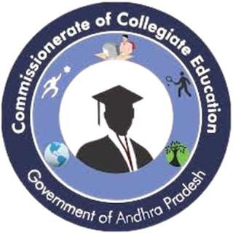
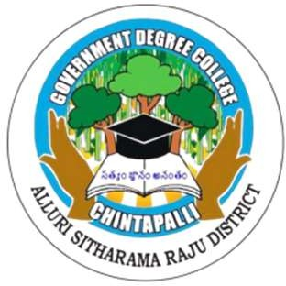
GOVERNMENT DEGREE COLLEGE
CHINTAPALLI, ALLURI SITARAMARAJU DIST - 531111
Affiliated to Andhra University

Academic Year 2025-2026

STUDENT MONITORING REPORT
(MENTOR & MENTEE)

IQAC Coordinator: K. Santhoshi Principal: Dr. M. Vijaya Bharathi

STUDENT MONITORING REPORT 2025-26
Student Mentor-Mentee Monitoring Report: 2025-26
Institution: Government Degree College
Supervision: Dr. M. Vijaya Bharathi Garu, Principal

Introduction
Under the visionary guidance of Principal Dr. M. Vijaya Bharathi Garu, Government Degree College has implemented a robust Student Monitoring System (Mentor-Mentee System) for the academic year 2025-26. This system is designed to provide personalized care to every student, ensuring that no individual is lost in the crowd. By bridging the gap between teachers and students, the institution aims to foster a conducive environment for both academic excellence and personal growth.
Objectives of the Program
The primary goals of the Mentor-Mentee initiative are:
- To provide academic guidance and monitor progress across all semesters.
- To identify and support "slow learners" while challenging "advanced learners."
- To offer psychological and emotional support through regular counseling.
- To encourage participation in extracurricular activities, NSS, and sports.
- To maintain a bridge between the college administration and parents.

Distribution and Allocation Strategy
To ensure fairness and comprehensive coverage, the college adopted an Equitable Distribution Model. All available teaching staff members were assigned a specific number of students drawn from the I, II, and III years.
Note: Students are mixed from all three years for each mentor to allow for peer-mentoring, where seniors can guide juniors under the supervision of the staff member.

Roles and Responsibilities of Mentors
Each staff member acts as a "Local Guardian" for their assigned mentees. Their duties include:
- Academic Tracking: Maintaining a record of internal marks, attendance, and university results.
- Regular Meetings: Conducting monthly sessions to discuss challenges in the curriculum.
- Holistic Development: Guiding students toward certificate courses, MOOCs, and career opportunities.
- Documentation: Maintaining a Mentor-Mentee Book containing the profile, contact details, and progress reports of each student.

Impact and Observations (2025-26)
The proactive involvement of Dr. M. Vijaya Bharathi Garu has resulted in:
- Increased Attendance: Mentors contact parents of students with low attendance, resulting in better classroom engagement.
- Early Intervention: Identification of students at risk of dropping out due to financial or personal reasons.
- Skill Enhancement: A marked increase in student registration for campus placement drives and competitive exam coaching.

Conclusion
The Student Monitoring System at Government Degree College stands as a testament to the institution’s commitment to student welfare. For the Academic Audit 2025-26, the records demonstrate a systematic, transparent, and empathetic approach to education that goes beyond the syllabus.

Submitted by: K SANTHOSHI
IQAC Coordinator

